SOFTWARE REQUIREMENTS SPECIFICATION

**For**

**JOB PORTAL SYSTEM**

**Prepared by:-**

*MITHUN VIJAY V M*

*LEELAVINOTHAN A*

*KARTHIKEYAN R*

# Introduction

## Purpose

## A job portal system serves as an online platform that connects job seekers with employers.The purpose of a job portal system is multifaceted and involves facilitating the entire job search and recruitment process. Job portals allow individuals to search for job opportunities based on their skills, qualifications, and preferences. They provide a centralized platform where job seekers can explore a wide range of job openings across various industries and locations. Companies can post job vacancies, making them visible to a large pool of potential candidates.

## Document Conventions

* + - Entire document should be justified.
    - Convention for Main title

Font face: Times New Roman Font style: Bold

Font Size: 14

* + - Convention for Sub title

Font face: Times New Roman Font style: Bold

Font Size: 12

* + - Convention for body

Font face: Times New Roman Font Size: 12

## Scope of Development Project

The development of a job portal system holds significant scope in the contemporary job market. With the increasing reliance on digital platforms for recruitment, the project aims to provide a streamlined and efficient solution for both job seekers and employers. The system's scope includes user-friendly interfaces for creating and updating profiles, advanced search algorithms for personalized job recommendations, and seamless communication channels. The development project also encompasses the creation of a robust resume database, facilitating quick and targeted candidate searches. The platform's accessibility from anywhere with an internet connection broadens its reach, fostering diverse talent acquisition for employers. Incorporating analytics tools enhances the project's value by providing valuable insights for employers to optimize their recruitment strategies. Additionally, the inclusion of career development resources adds a comprehensive dimension, making the job portal system a one-stop solution for individuals navigating the dynamic landscape of employment opportunities.

## Definitions, Acronyms and Abbreviations

JAVA -> platform independence SQL-> Structured query Language ER-> Entity Relationship

UML -> Unified Modeling Language

IDE-> Integrated Development Environment SRS-> Software Requirement Specification

## References

* + - Websites

 jira

Software Requirements (Microsoft) Second Edition By Karl E. Wiegers

Software Engineering: A Practitioner’s Approach Fifth Edition By Roger S. Pressman

* + - Websites

[**https://vdocument.in/job-portal-project-report.html**](https://vdocument.in/job-portal-project-report.html)

[**https://www.researchgate.net/publication/348295543_A_Online_Job_portal_management_system**](https://www.researchgate.net/publication/348295543_A_Online_Job_portal_management_system)

# Overall Descriptions

## Product Perspective

Use Case Diagram of Issue Tracking System

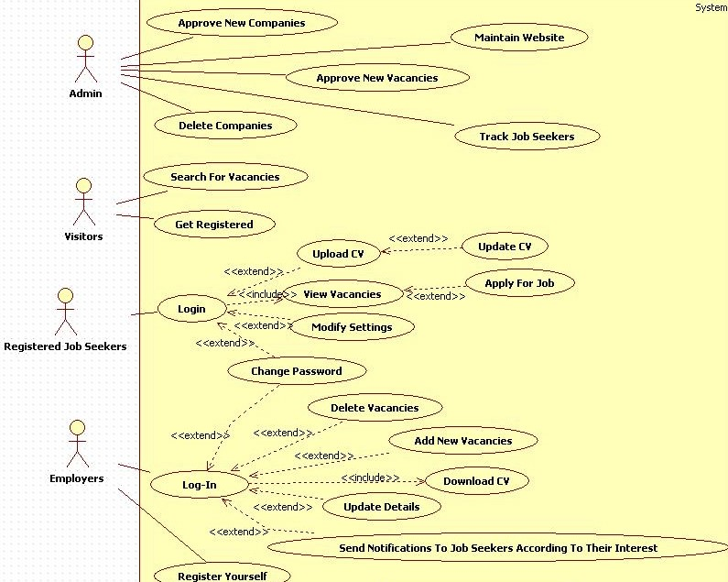

This Use Case Diagram is a graphic depiction of the interactions among the elements of Job Portal System. It represents the methodology used in sys- tem analysis to identify, clarify, and organize system requirements of Job Portal System. The main actors of Job Portal System in this Use Case Diagram are: Super Admin, System User, Company, Candidate, who perform the different type of use cases such as Manage Employer, Manage Employer Registration, Manage Post Job, Manage Interview, Manage Search Job, Manage Call Letter, Manage Users and Full Job Portal System Operations.

## Product Function

Entity Relationship Diagram of Issue Tracking System

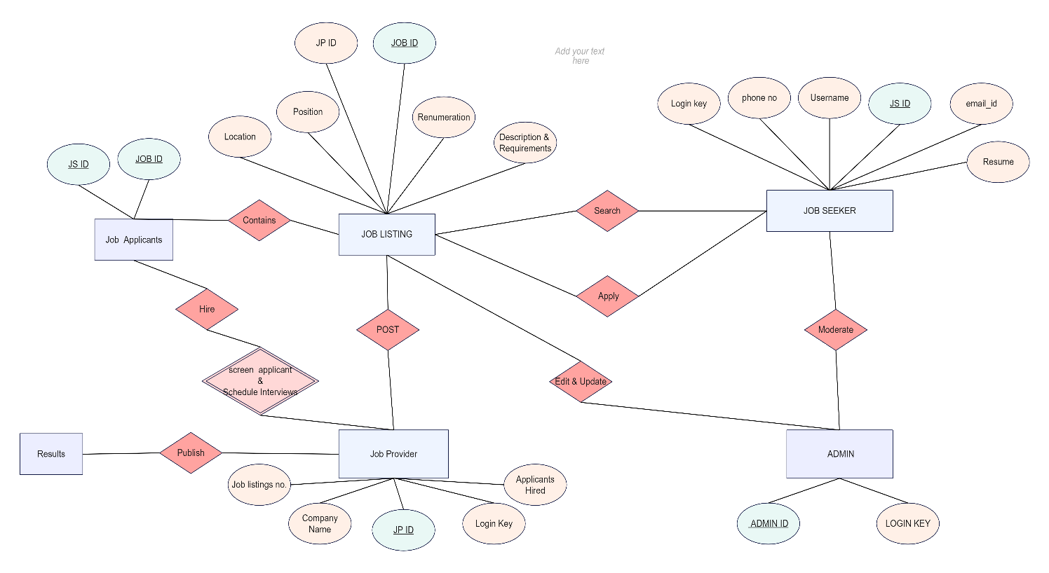vv

## A Job Portal or Job Provider ER Diagram shows all the visual instruments of database tables and the relations between Registration, Interview, Employee, Call Letter, etc. As you will learn in the ER Diagram below, it uses structured data and to define the relationships between structured data groups of Job Portal System functionalities. As you will see in the Job Provider ER Diagram below, the primary entities of the Job Provider ER Diagram are employee, registration, job, interview, search, and offer letter. It is recommended that you use EdrawMax Online to create similar-looking ER Diagrams for your assignments. The free ER Diagram maker comes with various features, like templates, symbols, and the ability to export in multiple formats. The collection of free ER diagram templates ease your effort in making the diagram as required.

## User Classes and Characteristics

In the context of an Job portal system, there will be two types of users: Employees and Job seekers.Employees will open the job availability and job seekers can apply for them.

The features that are available to the Developers are:-

* + - **Issue reporting and categorization.**
    - **Issue assignment and status tracking.**
    - **Collaboration tools for developers**
    - **Access control and communication channels**
    - **Customizable workflows**
    - **Reporting and analytics**
    - **Integration with other tools**

The features that are available to the Maintainers are:-

* + - **Customizable workflows**
    - **Access control and communication channels**
    - **Reporting and analytics**
    - **Integration with other tools**
    - **Backup and recovery**
    - **Security**
    - **Maintenance and support**

## Operating Environment

The product will be operating in windows environment. The Library Management System is a website and shall operate in all famous browsers, for a model we are taking Microsoft Internet Explorer,Google Chrome,and Mozilla Firefox.Also it will be compatible with the IE 6.0. Most of the features will be compatible with the Mozilla Firefox & Opera 7.0 or higher version. The only requirement to use this online product would be the internet connection.

The hardware configuration include Hard Disk: 40 GB, Monitor: 15” Color monitor, Keyboard: 122 keys. The basic input devices required are keyboard, mouse and output devices are monitor, printer etc.

## Assumptions and Dependencies

The assumptions are:-

* + - The coding should be error free
    - The system should be user-friendly so that it is easy to use for the users
    - The information of all users, books and libraries must be stored in a database that is accessible by the website
    - The system should have more storage capacity and provide fast access to the database
    - The system should provide search facility and support quick transactions
    - The Library System is running 24 hours a day
    - Users may access from any computer that has Internet browsing capabilities and an

Internet connection

* + - Users must have their correct usernames and passwords to enter into their online accounts and do actions

The dependencies are:-

* + - The specific hardware and software due to which the product will be run
    - On the basis of listing requirements and specification the project will be developed and run
    - The end users (admin) should have proper understanding of the product
    - The system should have the general report stored
    - The information of all the users must be stored in a database that is accessible by the Library System
    - Any update regarding the book from the library is to be recorded to the database and the data entered should be correct

## Requirement

Software Configuration:-

This software package is developed using java as front end which is supported by sun micro system. Microsoft SQL Server as the back end to store the database.

Operating System: Windows NT, windows 98, Windows XP Language: Java Runtime Environment, Net beans 7.0.1 (

Database: MS SQL Server (back end)

Hardware Configuration:- Processor: Pentium(R)Dual-core CPU

Hard Disk: 40GB

RAM: 256 MB or more

## Data Requirement

The inputs consist of the query to the database and the output consists of the solutions for the query. The output also includes the user receiving the details of their accounts. In this project the inputs will be the queries as fired by the users like create an account, selecting books and putting into account. Now the output will be visible when the user requests the server to get details of their account in the form of time, date and which books are currently in the account.

# External Interface Requirement

## GUI

* + - External interface requirements for a job portal system project define how the system interacts with external entities, services, and users .It allows user to view quick reports like Book Issued/Returned in between particular time.
    - It provides stock verification and search facility based on different criteria.
    - The user interface must be customizable by the administrator
    - All the modules provided with the software must fit into this graphical user interface and accomplish to the standard defined
    - The design should be simple and all the different interfaces should follow a standard

template

* + - The user interface should be able to interact with the user management module and a part of the interface must be dedicated to the login/logout module

User Interfaces:

Job Seeker Interface: Intuitive web interfaces for job seekers to create and update profiles, search for jobs, and apply for positions.

Employer Interface: User-friendly portals for employers to post job listings, review applications, and manage the recruitment process..

Data Import/Export:

Resume Import: Allow users to import resumes from popular file formats (e.g., PDF, Word) to populate their profiles.

Export Data: Enable users to download their data, including resumes and application history.

Search Engine Interfaces:

Search Engine Optimization (SEO): Optimize the platform for search engines to ensure better visibility of Job listings.

# System Features

The users of the system should be provided the surety that their account is secure. This is possible by providing:-

* User authentication and validation of members using their unique member ID
* Proper monitoring by the administrator which includes updating account status, showing a popup if the member attempts to issue number of books that exceed the limit provided by the library policy, assigning fine to members who skip the date of return
* Proper accountability which includes not allowing a member to see other member’s account. Only administrator will see and manage all member accounts

# Other Non-functional Requirements

## Performance Requirement

The proposed system that we are going to develop will be used as the Chief performance system within the different campuses of the university which interacts with the university staff and students. Therefore, it is expected that the database would perform functionally all the requirements that are specified by the university.

* + - The performance of the system should be fast and accurate
    - Library Management System shall handle expected and non-expected errors in ways that prevent loss in information and long downtime period. Thus it should have inbuilt error testing to identify invalid username/password
    - The system should be able to handle large amount of data. Thus it should accommodate high number of books and users without any fault

## Safety Requirement

The database may get crashed at any certain time due to virus or operating system failure. Therefore, it is required to take the database backup so that the database is not lost. Proper UPS/inverter facility should be there in case of power supply failure.

## Security Requirement

* + - System will use secured database
    - Normal users can just read information but they cannot edit or modify anything except their personal and some other information.
    - System will have different types of users and every user has access constraints
    - Proper user authentication should be provided
    - No one should be able to hack users’ password
    - There should be separate accounts for admin and members such that no member can access the database and only admin has the rights to update the database.

## Requirement attributes

* + - There may be multiple admins creating the project, all of them will have the right to create changes to the system. But the members or other users cannot do changes
    - The project should be open source
    - The Quality of the database is maintained in such a way so that it can be very user friendly to all the users of the database
    - The user be able to easily download and install the system

## Business Rules

A business rule is anything that captures and implements business policies and practices. A rule can enforce business policy, make a decision, or infer new data from existing data.This includes the rules and regulations that the System users should abide by. This includes the cost of the project and the discount offers provided. The users should avoid illegal rules and protocols. Neither admin nor member should cross the rules and regulations.

## User Requirement

The users of the system are members and Librarian of the university who act as administrator to maintain the system. The members are assumed to have basic knowledge of the computers and internet browsing. The administrators of the system should have more knowledge of the internals of the system and is able to rectify the small problems that may arise due to disk crashes, power failures and other catastrophes to maintain the system. The proper user interface, user manual, online help and the guide to install and maintain the system must be sufficient to educate the users on how to use the system without any problems.

The admin provides certain facilities to the users in the form of:-

* + - Backup and Recovery
    - Forgot Password
    - Data migration i.e. whenever user registers for the first time then the data is stored in the server
    - Data replication i.e. if the data is lost in one branch, it is still stored with the server
    - Auto Recovery i.e. frequently auto saving the information
    - Maintaining files i.e. File Organization
    - The server must be maintained regularly and it has to be updated from time to time

# Other Requirements

## Data and Category Requirement

There are different categories of users namely teaching staff, Librarian, Admin, students etc. Depending upon the category of user the access rights are decided.It means if the user is an administrator then he can be able to modify the data,delete, append etc. All other users except the Librarian only have the rights to retrieve the information about database. Similarly there will be different categories of books available. According to the categories of books their relevant data should be displayed. The categories and the data related to each category should be coded in the particular format.

## Appendix

A: Admin, Abbreviation, Acronym, Assumptions; B: Books, Business rules; C: Class, Client, Conventions; D: Data requirement, Dependencies; G: GUI; K: Key; L: Library, Librarian; M: Member; N: Non-functional Requirement; O: Operating environment; P: Performance,Perspective,Purpose; R: Requirement, Requirement attributes; S: Safety, Scope, Security, System features; U: User, User class and characteristics, User requirement;

## Glossary

The following are the list of conventions and acronyms used in this document and the project as well:

* + - Administrator: A login id representing a user with user administration privileges to the software
    - User: A general login id assigned to most users
    - Client: Intended users for the software
    - SQL: Structured Query Language; used to retrieve information from a database
    - SQL Server: A server used to store data in an organized format
    - Layer: Represents a section of the project
    - User Interface Layer: The section of the assignment referring to what the user interacts with directly
    - Application Logic Layer: The section of the assignment referring to the Web Server. This is where all computations are completed
    - Data Storage Layer: The section of the assignment referring to where all data is recorded
    - Use Case: A broad level diagram of the project showing a basic overview
    - Class diagram: It is a type of static structure diagram that describes the structure of a system by showing the system’s cases, their attributes, and the relationships between the classes
    - Interface: Something used to communicate across different mediums
    - Unique Key: Used to differentiate entries in a database

## Class Diagram

A class diagram is a specific kind of UML (Unified Modeling Language) diagram that is used to show how a system or software application is organized. It provides a visual representation of a system's classes, interfaces, and objects, as well as their relationships, characteristics, methods, and activities.

